®
Windows NT Server NetShow Services Deployment Guide

Abstract
NetShow™ Services is the latest release of the Microsoft® Windows NT® Server operating system streaming media services, which enable Internet Providers and organizations to deliver high quality audio and video at every bandwidth across the Internet or enterprise networks.
NetShow Services deployment guide is written for networking professionals and server administrators who have advanced knowledge of Microsoft Windows NT Server administration and networking concepts. This guide is not a general tutorial on Windows NT Server, NetShow Services, networking concepts, Internet security, or deploying servers on the Internet.

© 1998 Microsoft Corporation. All rights reserved.
The information contained in this document represents the current view of Microsoft Corporation on the issues discussed as of the date of publication. Because Microsoft must respond to changing market conditions, it should not be interpreted to be a commitment on the part of Microsoft, and Microsoft cannot guarantee the accuracy of any information presented after the date of publication.
This White Paper is for informational purposes only. MICROSOFT MAKES NO WARRANTIES, EXPRESS OR IMPLIED, IN THIS DOCUMENT.
Microsoft, the BackOffice logo, NetShow, Windows, and Windows NT are either registered trademarks or trademarks of Microsoft Corporation in the United States and/or other countries.
Other product or company names mentioned herein may be the trademarks of their respective owners.
Microsoft Corporation • One Microsoft Way • Redmond, WA 98052-6399 • USA
0498

Overview of the NetShow Services Deployment Guide 3
Contents
About NetShow Services 4
Key Features 4
Before You Begin 5
NetShow Services Applications 5
Usage Scenarios 7
Live vs. Stored Content 7
Hosting Live Events 7
Hosting Videos for Clients 7
Intranet with New Content Creation 8
System Requirements 9
NetShow Server Components and Administration Tools 9
NetShow Tools 10
Video Capture Cards 11
Microsoft Windows Media Player 12
Protocols and Security 13
Protocols 13
Security 16
Authentication 16
Authorization 16
Performance Issues 17
Bandwidth 17
Users 17
Controlling Clients and Bandwidth Usage 18
Server Capacity and Configuration 19
Building the Server 19
Base Server Platform 19
Disk Subsystem 19
Networking Configuration 20
Network Throughput 20
Connections and Bit Rates 21
System Testing 21
Generating Baselines 22
Monitoring Server Performance 22
The Test Environment 25
Test Scenarios 26
28-Kbps Max Client Connect 26
56-Kbps Max Client Connect 26
100-Kbps Max Client Connect 26
General Conclusions of the Tests 26
Simultaneous Streams 27
Live Streams 28
Server Processor Utilization During On-demand Streaming 29
Scaling NetShow Services 31
Cost/Benefit 31
Proposed Architecture for a Single Data Center 31
Efficient Backend Content Distribution 32
Redundant Live Distribution Servers 32
Improved On-demand Hosting 32
Increased Unicast Capacity for Live Events 33
Multiple, High-Bit-Rate Interconnection Points 33
Proposed Architecture for Geographically Distributed Data Centers 33
Support and Additional Information 35

Welcome to the NetShow™ Services deployment guide. This guide is written for anyone interested in learning more about deploying Microsoft® Windows NT® Server NetShow Services.

Overview of the NetShow Services Deployment Guide

This guide explores the best practices for configuring and testing NetShow Services in large-scale environments. Emphasis is placed on on-demand unicast services, because these are the most demanding from the architecture I/O standpoint. The guide provides guidance for operators of large-scale public networks and corporate network environments where large numbers of simultaneous users are anticipated.
This guide contains the following sections:
- About NetShow Services. Provides a brief introduction to NetShow Services and information about its capabilities.
- Usage Scenarios. Provides information about how NetShow Services can be used.
- System Requirements. Provides a list of hardware, software, and network requirements for NetShow Services.
- Protocols and Security. Provides information about protocols and security used by NetShow Services.
- Performance Issues. Provides information about NetShow Services performance issues.
- Server Capacity Planning and Configuration. Provides information about server capacity planning and configuration for NetShow Services.
- Support and Additional Information. Provides information about how you can get technical support and how you can find additional information about NetShow Services.
Microsoft Windows NT Server NetShow Services is a platform for streaming multimedia content over networks that range from low-bandwidth, dial-up Internet connections, to high-bandwidth local area networks (LANs). When companies, educational institutions, and other organizations use NetShow Services, they can stream multimedia content for applications such as employee training, corporate communications, entertainment, educational programs, and advertising to users all over the world. NetShow Services is a powerful broadcast system that is easy to operate.

About NetShow Services

Key Features
- Wide bandwidth range. Offers one of the industry's widest range of bandwidths for high-quality streaming, ranging from mono-quality audio of 2.4 kilobits per second (Kbps) to broadcast-quality video (with Microsoft NetShow Theater Server) of 8 megabits per second (Mbps). Provides high quality in the industry at every data rate.
- Intelligent streaming. Ensures that highest-quality video is delivered to users, regardless of network conditions.
- Highly scalable. Supports over 1,200 clients operating at 28.8 Kbps on a single-processor Pentium II server. Most cost-effective solution in the industry.
- Built-in multicast service. Conserves network bandwidth by delivering a single stream of high-quality video to support unlimited users.
- Fast video encoding. Encodes lengthy, on-demand content at the fastest rate in the industry, saving content producers valuable time.
- Seamless stream switching. Provides a smooth viewing experience by eliminating delay between linked content segments, regardless of data type.
- Scalable to full-screen. Video playback window can be increased up to full-screen.
- Codec independence. Ensures highest-quality streaming by providing the best compression schemes, and allowing content authors to choose the most appropriate codec for their application.
The key to the success of any server or software deployment is planning. Be sure to read this deployment guide and the Getting Started section of the NetShow Services documentation before installing the software.

Before You Begin
The following list contains informative documents and references about Windows NT Server Deployment tools with which you will want to be familiar. These guides can be found in the Deployment Tools Planning section in the Microsoft Windows NT Server section of the Microsoft Web site (http://www.microsoft.com/NTServer/Basics/NetShowServices/Deployment/default.asp)
- Domain Planning Guide
- TCP/IP Implementation Details
- Internet Presence (ATEC Course #859)
- Web Services Deployment Guide

In addition to the documents listed above, the following documents can be referenced:
- Windows NT Server Resource Kit
- Windows NT Hardware Compatibility List (HCL)
- NetShow Services product documentation
- Multicasting White Paper (available on the NetShow Services page in the Microsoft Windows NT Server section of the Microsoft Web site:
(http://www.microsoft.com/windows/ntserver/NetShow/about/whtpprs.htm)

NetShow Services Applications
Multimedia provides people with an exciting, new way to communicate. Moving images and sound add a new dimension to communication, and greatly enhance the power of text and graphics. Multimedia-enabled applications are the next wave of Internet-based technology, and NetShow Services provides the complete platform for integrating audio and video into Web-based applications to deliver advertising and retailing, corporate communications, entertainment and information, and training.

Advertising and Retailing
Web pages that use audio and video to advertise products or services can be much more compelling than Web pages that only rely on text and graphics for advertising. For example, on a Web site, you can use audio commentary with images to guide users through product demonstrations, processes, or the site itself. You can advertise and show a product or concept to its best advantage with the rich, synchronized sounds and images of NetShow Services illustrated audio.
When you use NetShow Services to promote and sell products on external Web sites, you can stream your messages to users. When users receive streamed messages, they can start to view them immediately without waiting for the entire movie or audio clip to download to their computer, thus avoiding frustrating delays.

Corporate Communications
Using NetShow Services, everyone in an organization, regardless of their geographic location, can hear important internal presentations or press briefings as they are presented. These same presentations can be captured for later playback to those who missed the initial, live presentation. Stored presentations can grow into a library of on-demand information for reference or training.
NetShow Services can reduce the burden of having employee’s travel to a central location for a training session by streaming the session over the corporate network to each employee’s computer.

Entertainment and Information
NetShow Services makes Web sites come alive with interactive audio and video content, from musical events to late-breaking news. Companies that already provide entertainment content on the Web can use NetShow Services to add visual content to their Web sites.
When companies combine NetShow server components with products like Microsoft Site Server Enterprise Edition, they can offer entertainment content on the Web for fun, and help justify the offering by using Site Server to sell products over the Web.

Training
Many organizations devote substantial resources to training employees. Using NetShow Services to extend the reach of professional instructors through corporate Intranets allows organizations to obtain the full value of their resource investment.

NetShow Services makes it easy for trainers to create training content, and for employees to receive this training whenever and wherever they need it. For example, a speech recorded in conjunction with a slide presentation can form a NetShow Services broadcast. The training material can be provided to all divisions and subsidiaries of a corporation, so all employees have the advantage of hearing the material delivered from the same speaker.

Delivering multimedia data and presentations over corporate networks and the Internet can help companies save money formerly spent distributing training materials in binders or on CD-ROMs. Because hard-copy materials go out of date quickly and are expensive to revise, the ability to update NetShow Services content immediately on the network can provide more current information and save money.
This section describes various scenarios in which you can benefit by using Microsoft Windows NT Server NetShow Services.

Usage Scenarios
Although there are many ways you can potentially use NetShow Services, this section focuses attention on the following scenarios:
- Live vs. Stored Content
- Hosting Live Events
- Hosting Videos for Clients
- Intranet with New Content Creation

Live vs. Stored Content
Microsoft Windows NT Server NetShow Services can host both live and stored events. There are different hardware configuration requirements for live vs. stored content. In live streaming scenarios there is lower disk I/O subsystem overhead. The hardware requirements of this subsystem are, therefore, minimized. However, if the bulk of your traffic is for stored content (Advanced Streaming Format [ASF] content stored on disk and served from a NetShow publishing point), pay close attention to the hardware and disk subsystem configuration that you use.

Unicast vs. Multicast
This paper is primarily focused on planning for unicast streaming, but recognizing that the differences between unicast and multicast streaming is important in planning your network and your hardware configurations. The total aggregate bandwidth requirements for multicasting are much less than those for unicasting, but the overall network configuration for multicasting could be more complex than for unicasting. For a more detailed discussion on multicasting, view the Multicast White Paper on the NetShow Services page in the Microsoft Windows NT Server section of the Microsoft Web site
(http://www.microsoft.com/NTServer/Basics/TechPapers/default.asp)

Hosting Live Events
One of the exciting things that Internet Service Providers (ISPs) can do with Microsoft Windows NT Server NetShow Services is the ability to broadcast live events on the Internet. These live events can be streamed remotely from the point of the ISP network service, meaning that events (such as concerts, conferences, company meetings, classes, or product demonstrations) can be captured onsite, encoded, and streamed to viewers in distant locations.

For example, a conference on the latest developments in medical research can be broadcast by an ISP using NetShow Services. This broadcast facilitates attendance by a wide audience including public health officials, medical personnel, educators, and interested community members without having them incur costly travel expenses.

Hosting Videos for Clients
Internet service providers that use Microsoft Windows NT Server NetShow Services can offer their customers the ability to distribute a wide range of stored content either as on-demand unicast or as scheduled broadcasts. The content can include items that are now offered on the Internet only as text with graphics.
For example, an ISP can offer a large medical institution that publishes a series of informational topics on the Internet, the chance to make available a series of first aid demonstrations. These first aid demonstrations can be offered on a pay-per-view basis, or on a members-only basis. Alternatively, the content can be an entire series of lectures on alternate transportation featuring transportation experts from around the country. The possibilities are rich and varied.

Intranet with New Content Creation
Microsoft Windows NT Server NetShow Services provide a powerful, rich means of communication on Intranets. Corporations with Intranets can use NetShow Services to reduce travel costs.

For example, a corporation can create training modules that can be viewed by associates located in several different cities around the world. These training modules can save the expense of having employees travel to a central location for training, and ensure that the training is consistent for all employees regardless of their geographical location.

If two large, national corporations merge, NetShow Services can be used to smooth the transition to a single corporate entity by streaming multimedia presentations of new policies over the corporate Intranet.

Institutions, such as universities can inform their entire communities about important, timely issues as events are happening by broadcasting updates on their intranet.
This section describes the hardware, software, and network requirements for Microsoft Windows NT Server NetShow Services.

System Requirements
Additional information is contained in the Microsoft Windows NT Hardware Compatibility List, which is available in the Microsoft Windows NT Server section of the Microsoft Web site (http://www.microsoft.com/NTserver/).
This section contains the system requirements for the following:
- NetShow Services
- NetShow Tools
- Microsoft Windows Media Player

NetShow Server Components and Administration Tools

The following table summarizes the minimum hardware and software requirements for NetShow Services.

Component | Recommended | Minimum for server | Minimum for admin only
Processor | Intel Pentium/100 megahertz (MHz) or Digital Alpha 1000a 5/300 | Intel Pentium/90 MHz | Intel Pentium/90 MHz or DEC Alpha 1000a 5/300
Memory | 64 megabytes (MB) or more | 48 MB | 32 MB
Network card | Ethernet card | Ethernet card | Ethernet card
Hard disk space | 21 MB; 6 MB for systems files and 15 MB for installation | 21 MB; 6 MB for systems files and 15 MB for installation
Software | Transmission Control Protocol/Internet Protocol (TCP/IP); Microsoft Internet Explorer version 4.01 or later; Microsoft Windows NT version 4.0 with Service Pack 3 (SP3) or later; | TCP/IP; Microsoft Internet Explorer 4.01 or higher; Windows NT Server 4.0 with SP3 or higher | TCP/IP; Microsoft Internet Explorer 4.01 or later; Microsoft Windows 95 with DCOM95

NetShow Tools
The following table summarizes the minimum hardware and software requirements for NetShow tools.

Component | Recommended | Minimum
Processor | Pentium II/266 megahertz (MHz) or Digital Alpha 533 based on the 21164PC chip. Transmission Control Protocol/Internet Protocol (TCP/IP). NetShow Encoder has been tested on dual- and quad-processor systems. These systems provide additional encoding capabilities over a computer with a single processor. | Pentium 100, TCP/IP
Memory (RAM) | 32 megabytes (MB) | 16 MB
Network card | Ethernet card | Ethernet card
Software | TCP/IP; Microsoft Windows 95 or Microsoft Windows NT Server version 4.0 with Service Pack 3 (SP3) or later (real-time encoding of audio and video up to 320 x 240 x 15 frames per second) | TCP/IP; Windows 95 (real-time encoding of audio only)
Audio card | A sound card compatible with Creative Labs Sound Blaster 16 | A sound card compatible with Creative Labs Sound Blaster 16
Video capture card | A video capture card that supports Video for Windows. See the Video Capture Card table. | A video capture card that supports Video for Windows. See the Video Capture Card table.

Video Capture Cards
The following table summarizes the supported video capture cards for NetShow tools.

Manufacturer | Video capture card | Operating system
Multimedia Access Corporation | Osprey 100 | Microsoft Windows 95, Microsoft Windows NT Server version 4.0 (x86 or Alpha)
ATI Technologies, Inc. | ATI All-in-Wonder | Windows 95
Hauppage Computer Works | Hauppauge WinCast/TV | Windows 95, Windows NT Server 4.0
Intel Corporation | Intel SmartRecorder III | Windows 95
Winnov | Winnov Videum | Windows 95, Windows NT Server 4.0
Winnov | Winnov VideumCam PCMCIA | Windows 95, Windows NT Server 4.0
Toshiba | Noteworthy Videophone PCMCIA | Windiws 95
Digital Vision | Digital Vision Computer Eyes/PCI | Windows 95, Windows NT Server 4.0

Microsoft Windows Media Player
The following table summarizes the minimum hardware and software requirements for Microsoft Windows Media Player.

Component | Recommended | Minimum for Media Player on Microsoft Windows 95
Processor | Intel Pentium/120 megahertz (MHz) or better; Digital Alpha 1000a 5/300 | Pentium 90 MHz
Color display card | 256-color display or better | 16-color display
Memory (RAM) | 64 megabytes (MB) or better | 16 MB
Network card | 28.8 kilobits per second (Kbps) modem or Ethernet card | 28.8 Kbps modem (optional for local playback)
Sound card | Sound Blaster 16 compatible sound card (x86); sound card supported under Windows NT (alpha) | 16-bit sound card
Software | Microsoft Windows 95, Microsoft Windows NT Server version 4.0 or Microsoft Windows NT Workstation version 4.0 with Service Pack 3 (SP3) or later | Windows 95 (audio, illustrated audio, and some video)

This section provides a brief introduction the various transport protocols and security measures that can be used by Microsoft Windows NT Server NetShow™ Services.

Protocols and Security

Protocols
Microsoft Windows NT Server NetShow Services transport protocols send content data across networks. The protocol used to access content on your servers has various implications for server performance.

NetShow Services supports four transport protocols, including: Internet Protocol (IP) Multicast, User Datagram Protocol (UDP), Transmission Control Protocol (TCP), and Hypertext Transfer Protocol (HTTP). Each protocol affects the server differently.

In addition to standard transport protocols, NetShow Services uses two protocols to transfer information between services and to transfer unicast data: Media Streaming Broadcast Distribution (MSBD) protocol and Microsoft Media Server (MMS) protocol.

This section includes the following topics:
- Internet Protocol Multicast
- User Datagram Protocol
- Transmission Control Protocol
- Hypertext Transport Protocol
- Media Streaming Broadcast Distribution Protocol
- Microsoft Media Server Protocol

Internet Protocol Multicast
Internet Protocol (IP) Multicast affects server performance less, and allows greater scalability than other protocols because it is a connectionless protocol. Network hardware and conditions are the only things that limit scalability and server performance. This protocol is used to establish one-to-many connections in which multiple clients can receive the same stream from a server. To receive a multicast, a client must have access to a multicast-enabled network. In contrast, a unicast is a one-to-one connection in which one client receives a distinct stream from a server.

User Datagram Protocol
User Datagram Protocol (UDP) is not a session-based protocol. It is often called a connectionless transport protocol. Only unicast UDP is discussed in this section. UDP, like Transmission Control Protocol (TCP), runs on top of Internet Protocol (IP) networks.

Applications that use UDP typically rely on other mechanisms to guarantee packet delivery. This has several implications that make UDP-based communication especially applicable to streaming media. Because UDP provides very few error recovery services, it is an efficient and direct way to send and receive datagrams over an IP network.

UDP does not provide guaranteed delivery, but it is useful when TCP would be too complex, too slow, or unnecessary. Packets that are not recovered in time to be useful are left out. This allows content to degrade gracefully.

Transmission Control Protocol
Transmission Control Protocol (TCP) is a connection or session-oriented protocol. Each client connection to the server requires a session setup and breakdown. TCP sessions ensure that packet delivery is completed without intervention from the application using the data. TCP is a more reliable transport that has higher overhead and is more complex than other protocols. Processor utilization and the additional bandwidth required for session setup, maintenance, and breakdown can affect servers.

For the client, TCP adds reliability, which can adversely affect the user experience. If the server is operating under a heavy load, or if there is latency or heavy congestion on the network, TCP causes the client to wait for all packets to be delivered before continuing. If packet delivery is delayed long enough, the player can pause and re-buffer, although it would continue if UDP was used.

Hypertext Transfer Protocol
To stream content through a firewall, you can enable Hypertext Transfer Protocol (HTTP) streaming on NetShow Services. HTTP streaming can be used to stream content from NetShow Encoder through a firewall to NetShow component services.

Firewalls
Many corporations use firewalls to prevent unauthorized access to their corporate networks. Firewalls filter the packets of information that pass across bridges, routers, or gateways, and control traffic between the corporate network and the Internet. Firewalls provide control by monitoring all packets and providing access to only those packets whose source and destination Internet Protocol (IP) address have been given authorization.

NetShow Services work with a variety of firewalls. For information on which firewalls NetShow Services work with, see the NetShow Services page in the Microsoft Windows NT Server section of the Microsoft Web site (http://www.microsoft.com/NTServer/Basics/NetShowServices/default.asp).

If you have problems streaming information past or receiving information through your firewall, you can open different ports on your firewall. Consult your firewall vendor and the following table to decide if you need to adjust your firewall to accept NetShow Services streaming. This table is designed from the perspective of a client inside a firewall that is receiving ASF streams from NetShow server components outside the firewall. Port In is the port that the server uses to get past the firewall. Port Out is the port that Microsoft Windows Media Player uses to communicate with the server.

Protocol | Port In | Port Out
MMS (multicast) | IP Address 224.0.0.1—239.255.255.255 | 1—65000
MMS-UDP (unicast) | 1755 (TCP) | 1024—5000 (UDP)
MMS-TCP (unicast) | 1755 (TCP) | 1755 (TCP)
HTTP | 80
MSBD | 7007 (TCP) | 7007 (TCP)
DCOM | 135 (TCP)

Hypertext Transfer Protocol (HTTP) streaming is useful for delivering streams over the Internet and past firewalls. It usually uses port 80, and most firewalls do not block port 80. Although NetShow Services is configured to use Microsoft Media Server (MMS) protocol streaming by default, you can configure NetShow server components to use HTTP streaming. Using HTTP streaming is the suggested method of streaming NetShow Services content past firewalls.

Media Streaming Broadcast Distribution Protocol
The Media Streaming Broadcast Distribution protocol (MSBD) is used to distribute streams between NetShow Encoder and NetShow component services. It is also used to transfer streams between servers.
MSBD is a connection-oriented protocol that is optimized for use with streaming media. MSBD is useful for testing client server connectivity and the quality of NetShow Services content, but it must not be used as the main method of receiving content. NetShow Encoder can support a maximum of 15 MSBD clients; NetShow server components can support a maximum of 5 MSBD clients.

Microsoft Media Server Protocol
The Microsoft Media Server (MMS) protocol is used to transfer unicast data. When a client connects using MMS, protocol rollover is used to obtain the best connection. MMS primarily attempts to connect using the MMSU protocol. MMSU is a protocol based on User Datagram Protocol (UDP). If the connection is not negotiated successfully, the client then attempts the MMST protocol. This protocol is based on Transmission Control Protocol (TCP). If that protocol cannot negotiate a good connection, Hypertext Transfer Protocol (HTTP) is then attempted.

Clients that connect to a multicast do not use a control protocol; they receive the data as it streams over the multicast IP address, and do not need to negotiate a connection.
Security in any computer system is a combination of technology and policy, that security depends on both technology and the manner in which systems are set up, managed, and supervised.

Security

The NetShow™ Services have built-in security features that integrate fully with Microsoft Windows NT Server version 4.0 to control access to content and Advanced Streaming Format (ASF) files or streams.

Windows NT security helps you protect your computer and its resources by requiring assigned user accounts. You can control access to all computer resources by limiting the user rights of these accounts. The settings for these features are configured easily by using NetShow Administrator and Microsoft User Manager (under Windows NT Server 4.0).

Authentication
NetShow server components can be configured to require clients to be authenticated before they can access NetShow unicast content. Authentication is the process of verifying the identity of a user, usually through a user name and password. When a user is authenticated, the security permissions for the user are read from the security database. This information is passed to the server, and either the requested title is opened or the request is rejected. Enabling authentication on NetShow server components allows you to control who can access NetShow Services content. Only one type of authentication can be presented to the client at a time, so the type must be determined before any attempt is made to authenticate the client.

Authorization
Authorization refers to a security feature for granting or denying access to protected resources based on the privileges of an authenticated user. For Microsoft Windows NT Server NetShow Services, the protected resources include content or media to which you want to control access, such as real-time content. Authorization works hand-in-hand with authentication, which confirms the user identity. In general, a user who fails authentication does not have permission to access the requested resource. A NetShow Services content provider can choose to grant an authenticated user limited or unlimited access to a requested title.

Performance Issues
The most important items to consider when planning the deployment of the Microsoft® Windows NT® Server NetShow™ Services are how many users you will serve and how much bandwidth the users will consume.
NetShow Services includes a custom set of Microsoft Windows NT performance counters that you can use to monitor the performance of NetShow component services and to measure their efficiently. These performance counters can be viewed in Microsoft Windows NT Performance Monitor, a standard tool in the Windows NT operating system.
This section contains the following topics:
- Bandwidth
- Users
- Controlling Clients and Bandwidth Usage

Bandwidth
In planning for the deployment of Microsoft Windows NT Server NetShow Services, you must determine how much bandwidth you need. To determine this, estimate how many concurrent users you will have on a regular basis and during peak times.
The amount of bandwidth you need to allocate equals the number of users multiplied by the stream size in kilobits per second (Kbps). If you are offering multiple bit rates, you can approximate the split between the bit rates for planning purposes. For example, suppose that you offer a live feed at two different bit rates, 28 Kbps and 56 Kbps, and that half of your traffic is at 28 Kbps and half is at 56 Kbps. For the 28 Kbps content, you would normally target about 22,000 Kbps, and for the 56k content you would target about 50,000 Kbps. If you support 1,000 users, you would require 36 megabits per second (Mbps) of bandwidth, according to the following calculation:
(1000*.5*22000)+(1000*.5*50000) = 36 Mbps
When calculating bandwidth requirements, use the actual bit rates. These recommendations come from the default bit rates in the NetShow Encoder templates. This guide does not discuss content creation and authoring considerations, but you can find information about the Content Creation Authoring Guide on the NetShow Services page in the Microsoft Windows NT Server section at http://www.microsoft.com/NTServer/Basics/NetShowServices/default.asp.

Users
It is difficult to project the number of users you need to plan for in a deployment because the number varies greatly from regular sustained traffic to peak traffic. You must consider not only the total number of concurrent users on a daily basis, but also the total number of concurrent users at peak times. You can plan a server configuration that handles a normal, sustained load, and you can integrate contingent services to meet peak demands.
In addition to the number of users, consider the size of the streams they demand. You can limit the size of the streams that you offer. When you determine the total number of users, you can calculate the aggregate bandwidth and number of servers you need to stream your content.

Controlling Clients and Bandwidth Usage
The NetShow Administrator General tab controls the limits on the number of clients and bandwidth usage. The limits you set affect the entire Microsoft Windows NT Server NetShow Services system. They affect any Advanced Streaming Format (ASF) stream delivered by the server. The following table describes the server properties you can set.

Property | Description
Maximum Connected Clients | This limits the number of clients that can be connected to the server at any given time. Minimum = 0; Maximum = No Limit.
Maximum Aggregate Bandwidth | This limits the amount of bandwidth that the server streams, and is measured in kilobits per second (Kbps). The upper limit must not exceed 85 percent of the capacity of the network card. Minimum = 1; Maximum = No Limit.
Maximum File Bitrate | This limits the amount of bandwidth at which any one file can be streamed. Minimum = 1 Kbps; Maximum = No Limit. The server does not attempt to stream any ASF content larger than the value specified in Maximum File Bitrate; this includes live ASF streams.

Server Capacity and Configuration
After you have determined how you will use Microsoft Windows NT Server NetShow™ Services, your available bandwidth, and how many users will connect to the system, you can calculate approximately how many servers you need to deploy.
- This section contains the following topics:
- Building the Server
- Networking Configuration
- System Testing
- Scaling NetShow Services

Building the Server
In general, it is recommended that you use a distributed approach, rather than a single configuration approach, in any high-volume situation. For example, it is better to deploy two dual- or four single-processor servers than a single quad-processor server. There are two main reasons for this approach:
- Eliminates a single point of failure by building redundant systems.
- Minimizes bottlenecks found in single mega-server configurations by distributing loads.

As a rough approximation (assuming unlimited bandwidth), plan for between 800 and 1,500 users per server based on your hardware configuration, stream size, and mix of bandwidths. The number of users per server can be less if you support high-bit-rate content, or more if you deliver only live streams.
The number of users varies depending on the hardware configuration. Limited bandwidth can create a bottleneck. For example, if you have the equivalent of a T1 line, it sometimes can be inappropriate to deploy a dual-processor server, and you can saturate your network connection with a single-processor Pentium 90.
This section contains the following topics:
- Base Server Platform
- Disk Subsystem

Base Server Platform
A good starting point for the server is a 266-megahertz (MHz) Pentium II, with 256 megabytes (MB) of random access memory (RAM). In any large-scale system, dual processor, 300-MHz Pentium II systems are recommended. In most large-scale high capacity configurations, 256 MB of RAM is an optimal configuration.

Disk Subsystem
Because disk output performance is a pivotal concern in streaming on-demand content, it is important to optimize the disk configuration in each server. The server must have three high-speed, low-access-time disks configured as a RAID 0 array using the Microsoft Windows NT disk administration tool. It is also possible to obtain improved throughput from hardware-based array controllers and from striping across multiple drive controllers.
Typically, more than three disks in each array do not increase performance because of bus saturation (some high-performance drives can saturate a drive chain with only two disks attached). Also, you can increase performance with dedicated memory on the hardware-based disk array controller. This allows the array controller to cache commonly accessed data.

Networking Configuration
Microsoft Windows NT Server NetShow Services do not use system memory (RAM) to cache file system data. Increasing RAM does not improve NetShow Services performance related to disk I/O issues. It is recommended that you configure the server to minimize the amount of memory used. This can be configured in the Network Control applet as follows:
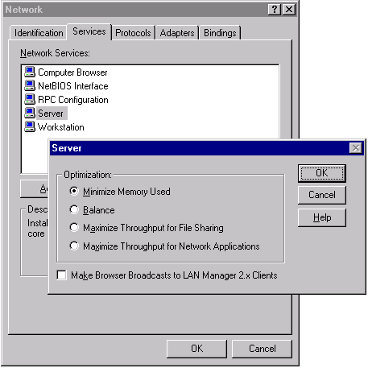
Network Control Applet

Network Throughput
The server must be connected with single or multiple network cards. To obtain best results from each of your servers, the network connection must be through a dedicated fast Ethernet (or OC3 ATM) switched network segment. You can consider using multiple network cards if you plan to monitor remotely, administer remotely, or use distribution streams from your server. This allows you to create multiple network segments and isolate your traffic to a particular network segment.

For example, you can use one network card for streaming content to clients, and you can isolate the other card to carry a distribution stream from another server or from a NetShow Encoder. The benefit of this configuration is that the distribution stream is not at risk if the client segment becomes saturated. When you monitor and administer remotely, you do not skew your server benchmarking results if bandwidth is used for purposes other than serving clients.

Connections and Bit Rates
Streaming long-playing files improves server performance because long-playing files have less impact on the server. Long-playing files, however, do not guarantee that users can view the entire file. If you are streaming live content or longer on-demand files, you can expect to stream content to more clients from a given configuration in contrast to streaming content to many clients accessing many shorter on-demand files.

Stream bit rates affect performance in several significant ways. High-bit-rate streams are more efficient with respect to the overhead of the transmission protocol. This means that in a high-bit-rate stream there is less overhead incurred in sending the data, but because more data is sent, the total aggregate network bandwidth is greater. Because of the larger stream size, fewer total streams can be delivered simultaneously in comparison to lower bit-rate streams.

In the best possible case, you are supporting access to low-bit-rate, live streams, and in a worst possible case, access to many short, high-bit-rate streams. Both establishing a connection and having clients use the fast-forward or rewind features can adversely affect the performance of the server, especially when these activities occur at high levels.

System Testing
After you have completed your deployment planning, and you have procured and configured your hardware, you are ready to begin testing and start formulating a baseline. A baseline is a measure of maximum system capacity and performance that is used to compare different configurations. It is the process in which you determine the maximum capacity of your configuration and monitor the effect of changes in the system.

Actual performance results obtained through production use or deployment of Microsoft Windows NT Server NetShow Services can differ from these results. Information presented in this document must under no circumstances be interpreted or construed as a contractual obligation by Microsoft to meet specific scalability requirements or product specifications. Results vary according to specific system configurations and/or network environments.
Note

Generating Baselines
To begin testing, you must first establish a baseline. You test and monitor your server to determine the expected capacity and to establish metrics to gauge the server performance in relation to other server configurations. You use available tools to monitor the overall activity and performance of the server.

During the initial deployment phases, you must monitor overall system stability and attempt to identify system bottlenecks. In later deployment phases you can use the baseline to compare systems and configurations, and to monitor the general system health.

Monitoring Server Performance
Microsoft Windows NT Performance Monitor is the single most important tool for generating a baseline and monitoring server performance. You can monitor Microsoft Windows NT Server NetShow Services performance counters locally and from remote servers. NetShow component services support several performance counters. For information about Performance Monitor, see the Performance Monitor online help.

The following is a list of important NetShow Unicast performance counters available in the Windows NT Performance Monitor.
Performance counter | Description
Active Streams | Number of active files or streams currently being sent to clients. Provides an overall indicator of system activity. Note that a client is connected even if it has stopped playing a file because the NetShow Unicast service maintains the bandwidth allocation to that client for 60 seconds after the client stops playing (this is called the Client Inactivity Time-out period). When the Client Inactivity Time-out period expires, the server actively checks the status of each client by periodically sending a message to each. The server keeps a client connection open as long as the client responds to a message within three minutes (this is called the Client Terminal Time-out period).
Active TCP Streams | Number of active Transmission Control Protocol (TCP) streams currently being sent to clients.
Active UDP Streams | Number of active user datagram protocol (UDP) streams currently being sent to clients.
Aggregate Read Rate | Sum of the read rates for all files being sent to clients, in bytes per second (bps). Indicates the speed at which the server is reading data from the disk. The performance monitor graph usually appears jagged because the block read time is shorter than the block sends.
Aggregate Send Rate | Sum of the send rates for all files being sent to clients, in bytes per second (bps). Indicates the speed at which the server is sending data to the clients. The performance monitor graph must appear relatively smooth; a jagged graph can indicate that streams are competing for bandwidth.
Connected Clients | Number of clients currently connected. Indicates all Microsoft Windows Media Player connections to the system. This includes clients streaming, clients in paused and connected states, and clients that the server has not yet detected as being disconnected. The latter condition can occur if a client has lost power or has been disconnected from the network and has not been able to notify the server of termination. After the Client Inactivity Time-out period elapses (60 seconds), the NetShow Unicast service actively checks the status of each client by periodically sending a message to each. Clients must reply to the message within three minutes in order to maintain their connection to the server (this is called the Client Terminal Time-out).
HTTP Streams | Number of active Hypertext Transfer Protocol (HTTP) streams currently being sent to clients.

The following is a list of optional performance counters.
Performance counter | Description
Active Live Unicast Streams | The number of live unicast streams that are being streamed.
Allocated Bandwidth | Amount of bandwidth that the server allocates, based on the number of current Media Player connections. Generally, clients connected to NetShow Services that are not receiving streams still are allocated bandwidth. If a media player has allocated bandwidth but does not send a command during the Client Inactivity Time-out period (60 seconds), its bandwidth is no longer allocated.
Connection Rate | The rate at which clients are connecting to the server. This counter is useful for correlating client connections with utilization of system resources.
Late Reads | The number of late read completions per second. A late read is a disk read operation that takes significantly longer than expected to be completed. Typically, this counter is non-zero only when the server is under a very heavy load. If this counter is often non-zero, this can indicate that the system is not properly configured (for example, possibly you must use additional hard disk drives or use a lower setting for the maximum number of clients) or that other applications are competing with NetShow Services for the use of the disk.
Scheduling Rate | The rate at which requests are being made for tasks to be scheduled, in tasks per second. The only tasks that currently are scheduled are loading files and streams to the network. The scheduling rate is roughly proportional to the rate at which packets are being sent by the server (this rate does not represent a one-to-one correspondence).
Stream Errors | The number of errors occurring per second. Stream errors represent the number of stream data packets discarded by the server. They are introduced by the server when it cannot keep up with the demand for data, and must throw some packets away to avoid running behind schedule indefinitely. Stream errors show up most often after late reads occur. They indicate that the system is not configured properly or that other applications are competing for system resources. Heavy network traffic also can contribute to stream errors.
Stream Terminations | The rate at which streams are terminated due to errors. Stream terminations indicate that the system is not configured properly or that the file being streamed is corrupted. The server unilaterally terminates a stream under certain circumstances—most commonly when the server is running significantly behind schedule. If the server must throw away several packets in a row from a given stream to remain on schedule, it terminates the stream. Streams also can be terminated if invalid data is encountered during file streaming.

The Test Environment
Included here is an interpretation of data captured during the course of Microsoft internal testing of Unicast on the NetShow Services. The tests were conducted to determine the actual performance of Unicast under peak and normal operating conditions.

The tests were conducted in the following environment:
- Network Environment: 100 Mbps Switched Ethernet LAN
- Unicast ASF Data Sources:
28 Kbps On-demand | 56 Kbps On-demand | 100 Kbps On-demand
28 Kbps Live | 56 Kbps Live | 100 Kbps Live

Streams were generated with the following configuration on each of the client computers:
- 200-MHz Pentium
- 64 MB of RAM
- Microsoft Windows NT Workstation version 4.0, Microsoft Windows NT Server version 4.0, Service Pack 3; Microsoft Windows 95
- Microsoft Windows Media Player

The following server configuration was used:
- Single-processor: 300-MHz Pentium II
- 256 MB of RAM
- Windows NT Server 4.0 with Service Pack 3
- NetShow Services
- 2 striped 4-gigabyte (GB) SCSI disks
- 100-Mbps Fast Ethernet network card

Test Scenarios

28-Kbps Max Client Connect
Server performance was assessed at and beyond the point where the maximum number of connected clients accessing 28-Kbps on-demand streams can be sustained. The max client numbers represent the point where late disk reads and network latency caused server performance degradation and client connection failures.

56-Kbps Max Client Connect
Server performance was assessed at and beyond the point where the maximum number of connected clients accessing 56-Kbps on-demand streams can be sustained. The max client numbers represent the point where late disk reads and network latency caused server performance degradation and client connection failures.

100-Kbps Max Client Connect
Server performance was assessed at and beyond the point where the maximum number of connected clients accessing 100K on-demand streams can be sustained. The max client numbers represent the point where late disk reads and network latency caused server performance degradation and client connection failures.

Additionally, tests are reported for unicast broadcast (that is, live event distribution) at 28Kbps with 256 MB of RAM. This scenario is compared directly to the matching on-demand scenario.

General Conclusions of the Tests
The performance of the unicast server running NetShow Services is linked to performance of disk access, memory configuration, and LAN traffic. Test failures occurred for on-demand streams as disk response deteriorated and corresponding late reads were observed through Windows NT Performance Monitor.

By comparison, live streams began to fail as LAN congestion increased and neared wire speed. The need to retransmit data causes the aggregate send rate to exceed the allocated bandwidth. At this point, the number of Active Streams levels off and the server does not accept new connections.
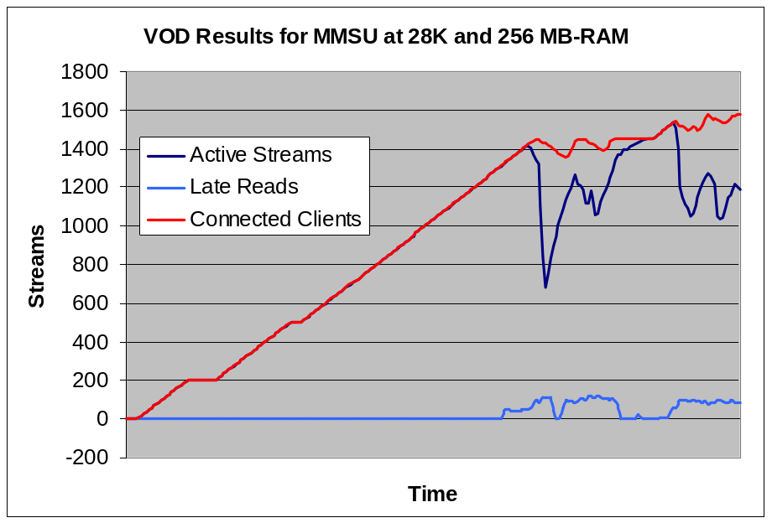
On-demand results for MMSU at 28 Kbps and 256 MB of RAM
The preceding chart describes this behavior. Active Streams and Connected Clients remain synchronized until late disk reads occur. The same behavior was observed at varying points for each protocol tested

These tests were conducted with two 4-GB SCSI disk drives striped using Windows NT disk administration tools. Adding a third disk to the stripe set, without parity, improves performance by pushing the occurrence of late reads to the right.

The processor usage in the server is roughly 40 percent when Late Reads occur in this scenario. Processor utilization varies greatly according to protocol, with MMSU being most efficient.

Simultaneous Streams
The following chart displays the maximum number of sustainable client connections at three bit rates and two levels of RAM. Slight differences in the number of connections are evident between each protocol. The primary conclusion can be drawn from the rate at which Active Streams and Client Connections drop out with increased stream bandwidth (that is, the server and the network will support more concurrent 28 Kbps streams than 100 Kbps streams). This is the expected behavior.
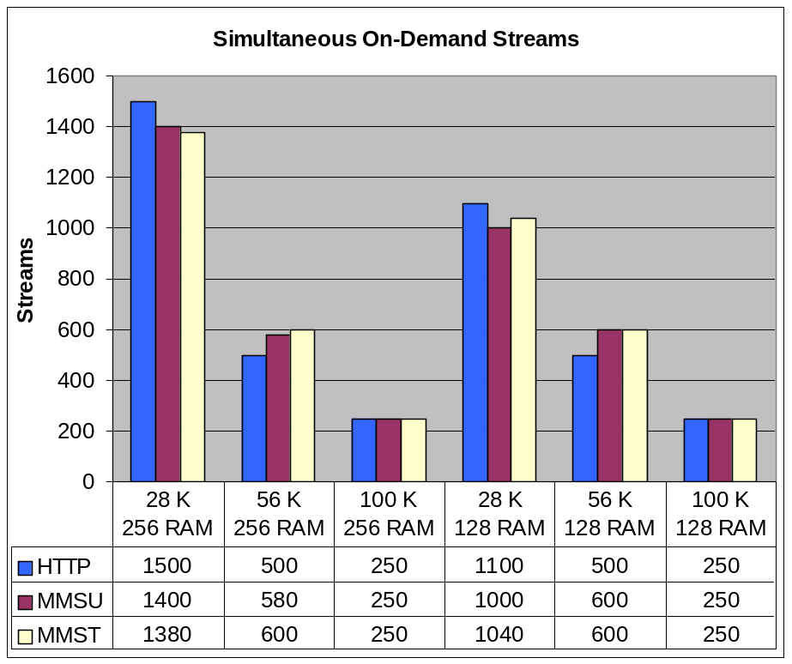
Simultaneous on-demand streams
As shown in the preceding illustration, the server configured with 256 MB of RAM can support roughly 1,400 concurrent ASF sessions without degrading the client experience. Hypertext Transport Protocol (HTTP) appears to be most efficient for transmission of smaller 28-Kbps streams while MMS-UDP is more efficient for larger bandwidth streams. HTTP is most frequently used to connect clients to the Internet through firewalls. Internet content is typically produced using lower bit rates to accommodate dial-up users with slower connections.

Live Streams
Live streams are not tied to disk performance. In the Live tests, performance degradation came later, and was related to processor and network bandwidth utilization.
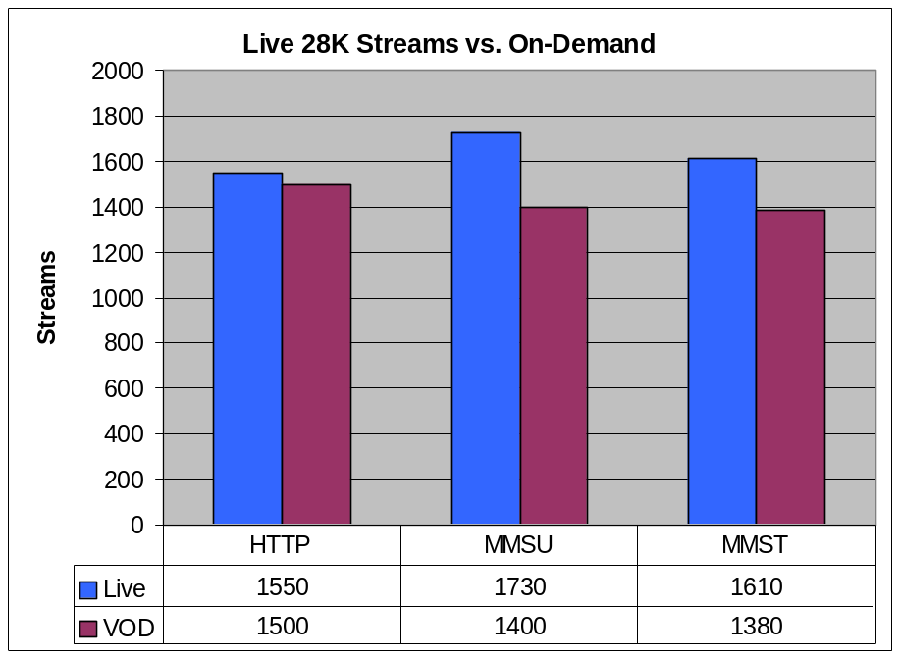
Live 28-Kbps streams vs. on-demand streams

Server Processor Utilization During On-demand Streaming
The following graph shows the Processor Time utilization as captured by Performance Monitor.
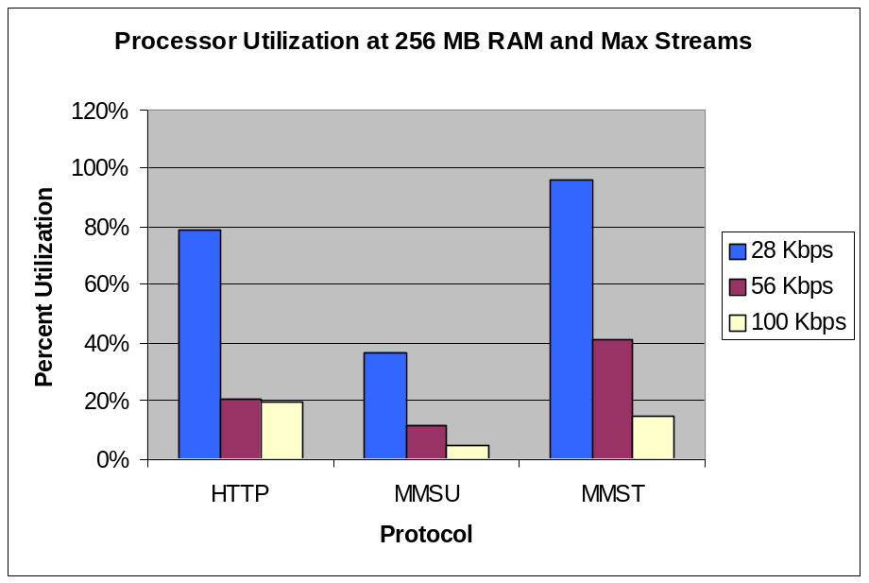
Processor utilization at 256 MB of RAM and Max Streams
This chart illustrates two expected, and important, factors. First, more streams (that is, smaller streams at Max Load) place a greater burden on the processor. This is expected because each stream has decisions associated with it. For example, each client connection must be acknowledged by the server, the allocated bandwidth must be checked, more re-send messages (associated with data loss) must be processed, and data about the stream quality must be monitored.

The second factor is the relative efficiency of the protocol that is being used. MMS-UDP requires less processor use at every stream bandwidth than is required for HTTP or MMS-TCP. This is also expected because UDP/IP data transmissions are connectionless protocols.

Processor utilization during live stream testing reached 100 percent, and became the effective bottleneck.
Note

Scaling NetShow Services
It is possible to develop scaling scenarios for large deployments of Microsoft Windows NT Server NetShow™ Services. This section describes an example for scaling NetShow Services in a single-facility setting. Another scaling scenario (not fully detailed here) involves geographic distribution of NetShow server components across multiple-network operation points.

The following questions must be considered when planning a large NetShow Services deployment:
- By adding memory, processors, network cards, and high-throughput disk arrays, is it possible to generate more streams from a single server?
- Does NetShow Services scale linearly on one computer?
- When does it make sense to add more computers?

In other words, must you buy huge, expensive computers and push them to the limit? To answer this, consider the live and on-demand scenarios discussed earlier.

In the on-demand scenarios, Late Reads directly correlated with degradation of client connections. By adding more drives in striped arrays, or by using higher performance equipment, it is possible to boost overall data throughput.

In the live scenario, the server supports 1,730 active 28-Kbps streams. The server is generating roughly 48 Mbps of data output across the Fast Ethernet network (more than the capacity of a DS3. At this point the server’s processor utilization was observed at 100percent (as noted earlier). By adding more processor capability, it sometimes is possible to boost output.

In the live scenario, test data does not suggest that additional processors allow additional linear scaling. A point of diminishing returns is reached. In each scenario, the aggregate output gets close to the practical limits of the technologies in the test environment.

Cost/Benefit
Both Fast Ethernet technology and the servers in this environment are considered very reasonably priced. Moving to asynchronous transfer mode (ATM) switched networks and high-capacity servers with four processors and large amounts of memory can help to achieve higher throughput, but sometimes does not compare well in a cost/benefit analysis. In addition, very high-end server scenarios have not been tested thoroughly as vehicles for NetShow Services scaling.

It is recommended that large-deployment environments use other scaling methodologies. A commonly used method that scales services across multiple servers is discussed in the following section. Beyond the benefit of increased data output capability, there is also inherent fault-tolerance in this methodology.

Proposed Architecture for a Single Data Center
This scenario describes a situation in which a redundant array of NetShow server components is used to stream large amounts of content to large numbers of connected clients from one data center.
This scenario uses DNS Round Robin to aggregate the service into one or two DNS names. The dashed lines depict the content flow from encoders or distribution servers for multicast station servers while the dotted lines detail unicast broadcast flows. CNames for each bank of servers can be divided (as shown), or aggregated into one name. Each bank can support multiple names (this is a function of DNS and is not limited by NetShow Services).
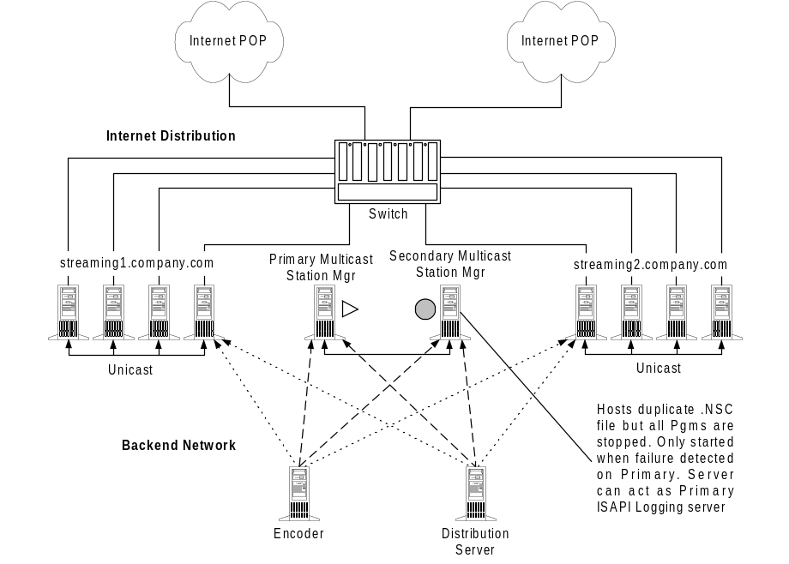
Architecture for a single data center

Efficient Backend Content Distribution
The distribution of live content is improved by using a backend network with a NetShow encoder and a distribution server. This improves performance and network utilization on the Internet side of unicast servers. Rather than pulling and serving the content via the front end, the content can be pulled from the backend network and then streamed to the Internet via the other network card. On-demand content can be stored on disk arrays that are directly attached to the appropriate servers or, alternatively, on a shared file storage array. Content replication can be easily managed with products such as Microsoft Content Replication Server (CRS).

Redundant Live Distribution Servers
This example uses redundant source servers for the live content distribution. Each unicast server pulls content from another unicast server. This helps to mitigate failure and increase available data output (that is, only two servers can be affected by a single distribution failure, rather than the entire site).

Improved On-demand Hosting
Rather than building eight identical computers to serve approximately 20 gigabytes of on-demand content, it is possible to split on-demand contents into two or more logical groups with DNS CName groupings. Long-term storage and short-term storage is one supported scenario in this configuration. For example, content that needs to be stored or archived for any period of more than three months can use the long-term servers while all other content is served from the remaining servers.

Increased Unicast Capacity for Live Events
Unicast data output capacity is improved by utilizing DNS Round Robin to balance the load across many servers.

Multiple, High-Bit-Rate Interconnection Points
By selecting multiple network connection points, reliability and throughput can be enhanced. Additionally, when possible, it is important to select multiple data carriers. Outages often occur within the infrastructure of a large network operator, but less frequently across multiple operators.

Proposed Architecture for Geographically Distributed Data Centers
In this example, the approach is less focused around the server. Scaling and availability are achieved with geographic distribution, content distribution and replication, intelligent routing, and value-added networking services (for example, quality of service [QoS], fault detection, and redirection).
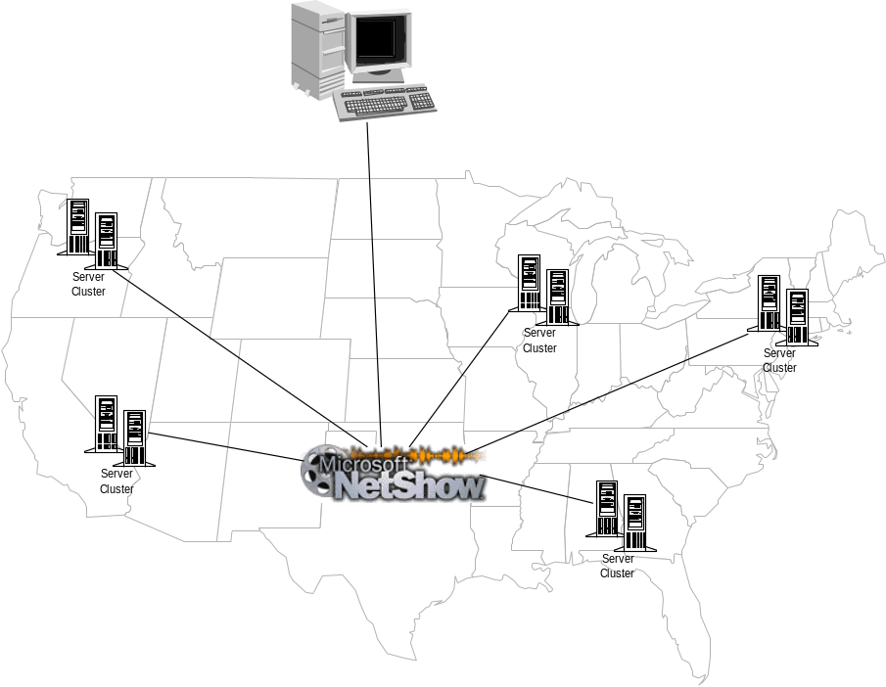
Architecture for geographically distributed data centers
In this example, the network operator takes advantage of intelligence that becomes embedded in the network architecture.
In its simplest form, this could be DNS direction services in each location. When a client requests data from NetShow server components in the New York office (for example, via the DNS name NetShow.company.com), the local DNS server resolves this to the eastern server cluster (that is, the closest server). Likewise, when a client requests data from NetShow server components in the Los Angeles office (for example, via the DNS name NetShow.company.com), the local DNS server resolves this to the western server cluster (that is, the closest server).
More sophisticated examples include deployment of network redirection and fault-detection services. These methods can be network-specific (that is, require direct network attachment). These are typically known as Virtual Private Network (VPN) services, and offered as value-added network services (reliability increases in closed systems).

In broader Internet-related deployments, this can function via public routed networks with well managed connection points and direction services. This is sometimes achieved through source IP detection and dynamic DNS services. Various network providers have implemented proprietary mechanisms for this as well. Examples include MCI’s Virtual Multicast Services, and GTE Internetworking’s Hopscotch-enabled network services and RSVP-enabled backbone.
This section identifies other resources for additional information about Microsoft® Windows NT® Server NetShow™ Services.

Support and Additional Information
- For additional information about NetShow Services in general, see the NetShow Services page in the Microsoft Windows NT Server section of the Microsoft Web site (http://www.microsoft.com/NTServer/Basics/NetShowServices/default.asp).
- For NetShow Services Live Events, Live Audio, Live Video and Samples, see http://www.microsoft.com/windows/windowsmedia/techshowcase/default.asp
- For more information about developing Web pages and content for NetShow Services, download the NetShow Content Creation and Authoring Guide available from the NetShow Streaming Media Services download page at http://www.microsoft.com/windows/downloads/contents/updates/ntnetshowservices/default.asp
- For more information about NetShow Services ASF specifications, see http://www.microsoft.com/asf/specs.htm
- For additional information about codecs, see the NetShow Encoder Quickstart wizard
- For news group on NetShow Services, see news:microsoft.public.NetShow
- To subscribe to the NetShow Listserv
Send an e-mail message to Listserv@discuss.microsoft.com
Leave subject blank
For message text, type: “subscribe NetShow” and your name

For technical support, see http://www.microsoft.com/ntserver/NetShow/support.htm

